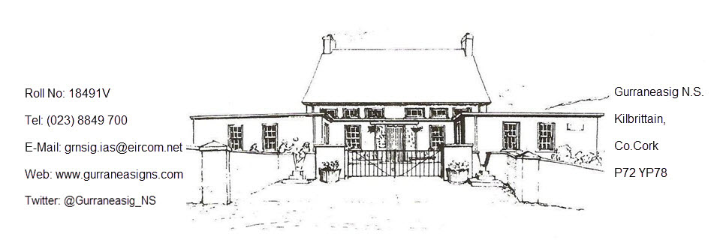

                                                                                                                       10 September 2024

***Dear Parents,***

***Welcome to Our New Students and Teacher!***

*We are thrilled to extend a warm welcome to our newest Junior Infants: Alexander, Cuan, Katie, and Niamh! We hope you are excited to start your learning journey with us, and we can't wait to see all the amazing things you will achieve.*

*A special welcome also goes out to the students who have joined us in other classes throughout the school: Hannah, Darwin, Indigo, Amber, Maya, Rachael, and Oran. We are delighted to have you as part of our school community, and we know you'll make wonderful new friends and memories here.*

*We are also excited to welcome our new teacher, Mr. Seamus O'Driscoll, to the team! Mr. O'Driscoll's family has a long-standing connection with our school, as his mother is a past pupil. We are certain that you will all join us in giving Mr. O'Driscoll a warm Gurraneasig welcome.*

***School Opening hours***

*09:30 - 15:10 hrs*

*09:30 - 14:10 hrs (Junior & Senior Infants)*

*Please note that children should not be on school grounds before 9.20am.  A member of staff will open the school doors at 9.20am*

***Pupil Absence***

*Should your child be absent/late/early leaving from school please inform us by email.*

*The school’s obligations under Tusla (The Educational Welfare Services of the Child and Family Agency) guidelines specify that any child with 20 days absence (or greater) have to be reported to Tusla.  As a forewarning on approaching that absence level, our school will send a notification to the parents of a child who has reached 15 days absence. The Sign-Out Register will be in operation again this year. Please sign out your child if they are leaving the school early for any reason. This register is located on the desk in the hall.*

***Parental Concerns and Meetings***

*We kindly ask that all meetings with teachers be scheduled in advance, especially in the mornings when teachers are busy preparing their lessons for the day ahead. The Parental Complaints procedure is available on the school website, and we ask that all queries or concerns be addressed directly to the teacher first before being escalated further. Thank you for your cooperation!*

***LEANS Programme***

*We are excited to announce that we will be trialling the LEANS programme in the Middle and Senior Room as part of our Wellbeing plan. LEANS is a curriculum designed to introduce pupils to the concept of neurodiversity and help them explore how it impacts experiences at school. Through this programme, we hope that children will gain insights and understanding of their own learning styles as well as those of their peers, fostering a greater sense of understanding and inclusion within our school community.*

***Green Schools/Student Council***

*Our Green Schools and Student Council initiatives will be getting up and running this month! These programmes offer fantastic opportunities for our students to take an active role in promoting environmental awareness and contributing to school life. We look forward to seeing the creative and inspiring ideas they will bring to the table.*

***Library Bus***

*We are pleased to announce that the Library Bus will resume its visits every Friday. Please note that a few titles went astray before the summer holidays, and we would greatly appreciate a quick check at home to help locate any missing books.*

***Internet Safety Talk***

*We have the great privilege of welcoming Ger Brick to conduct an internet safety talk with our 3rd-6th Class students. Ger Brick is an experienced facilitator who delivers Cyberbullying and Internet Safety talks to Primary Schools across Ireland. With over 20 years of practical industry knowledge, including 17 years as an IT Program Manager, Ger is well-equipped to engage with both children and parents at their level.*

***Creative Clusters***

*We are delighted to announce that we have been selected to take part in a two-year initiative with other local schools called Creative Clusters. Currently, we are in the introductory stage with training and preparation, but soon we hope to share much more about this exciting project. We look forward to collaborating with our cluster schools and bringing creativity to the forefront of our learning experiences!*

***Say Yes to Languages***

*We are pleased to share that we have successfully secured another year of the Say Yes to Languages Programme. This means that Oscar, Vita’s dad, will be delivering Spanish lessons to the Middle and Senior Rooms very shortly!* ***¡Gracias, Oscar!***

***Parents Association***

*We would like to extend a very special thank you to the Parents Association for their incredible fundraising efforts for our Cosy Corners Initiative. This wonderful initiative will look a little different in each classroom: the Junior Room will have a Calm Corner, the Senior Room will have a Flexi Seating Corner, and the Middle Room's corner is currently being designed! We are excited to see how these spaces will enhance our students’ learning environments.*

***School Closures***

*Please be aware that there will be two additional school closures this term. We will have a mandatory closure on October 3rd to facilitate staff training and an additional half-day closure on November 21st for further staff training.*

***Books***

*The Department of Education has facilitated the buying of school books this year. We ask that these books are cared for and looked after properly. Any damaged books will need to be replaced. Thank you for your cooperation!*

***Term Fees***

*The school still requires parents to contribute towards Art & Craft supplies, photocopying expenses and other sundry costs associated with running the school. The cost of which will remain the same as it has done for the past few years of* ***€45 per pupil for three terms****. These term costs can be transferred to the school account (see below)*

***Pupil Accident Insurance & Parents Association Public Liability Insurance***

*Please note the PA who organise payment of these invaluable insurance policies have asked that when you are paying your Term costs could you please add on your payment of €10 for these 2 Policies.   €8 per child*

*(24-hour cover) for the Pupil Accident Insurance and €2 for the Public Liability Insurance.*

***Allied Irish Bank***

***South Main Street***

***Bandon Co. Cork***

***Account Name:  Gurraneasig National School 1 Account***

***IBAN:   IE61AIBK93404607304047***

***BIC:   AIBKIE2D***

***For reference please put your child's name & item (Tour, Term cost etc) so we will know to whom the transaction applies.***

***Traffic / Speeding***

*Please be mindful of all others travelling to school. We have some families who walk and cycle to school, which is an Active & Green school activity, that we encourage. Please supervise your children when walking or cycling and ensure they do not progress too far ahead of you.  Children should observe the rules of the road and walk or cycle on the correct side of the road. Please use the school path to approach the school gate.*

***School Uniform***

*The official tracksuit uniform is a red polo shirt with/without crest and a navy tracksuit with red piping & a crest on the sweater. Shoes / trainers are to be plain, dark & flat.*

*Plain navy trousers / unbranded tracksuit bottoms are an alternative, and during the summer months, plain navy shorts are an option as well. Girls can also wear a plain navy skirt / pinafore with red or navy tights or long socks. Other than the school crest, no decorations / patterns / other crests or logos please on any item of clothing.*

*Spare Uniforms are available in the porch.*

***School Calendar 2024/2025***

*Please see the attached School Calendar for all School Holidays*

***Car parking & One-way system***

*Our informal one way system works well for the school during our start & finish times.*

*If you don’t know about it, please ask. The one way is used by the parents of the school.*

*Please be considerate to the locals, they are not party to this informal one way system, so be prepared to meet traffic. The local community uses the road as normal.*

*Please be aware and DRIVE SLOWLY & CAREFULLY.*

1. *Always slow your speed in the vicinity of the school.*
2. *Parents are requested NOT TO PARK IN THE ENTRANCE TO THE SCHOOL on the yellow box, but to park safely in the school vicinity. Please DO NOT PARK ON NEIGHBOURS GRASS.*
3. *DO NOT BLOCK neighbouring entrances / laneways or any access areas.*

*Thank you for your continued cooperation in promoting the health & safety of our school community.*

***Here's to a fantastic year ahead for everyone!***

Is mise le meas



Ms Maeve Tighe

Príomhoide